Research Title:

The Methodology of Level Design and Its Application in Third-Person Action Games: Combat, Narrative, Guidance/Hints

Research Project Introduction:

This research is based on my personal experience and has evolved from it. As a junior game designer who has recently entered the industry, I have encountered difficulties, raised questions, and have been curious about the level design process of games from my perspective. In my undergraduate research project, I posed the following research questions regarding level design: "How does level design impact players' combat experience and engagement? How can an engaging combat experience be reflected in linear-level structure?"

In this research, I narrowed down the focus of the broader level design area to emphasize the design of combat environments. The aim is to create high-quality battle scenes/arenas that provide players with an immersive or engaging gaming experience that highlights combat as a crucial mechanism in the game. Using the data and results obtained from the research, a linear game was constructed to reflect these findings in the level design.

Based on my research findings, I began creating prototypes and final projects. However, I found the process confusing and puzzling as I struggled to effectively incorporate the theoretical answers I had obtained into my creative process. This difficulty may have been due to my lack of design experience.

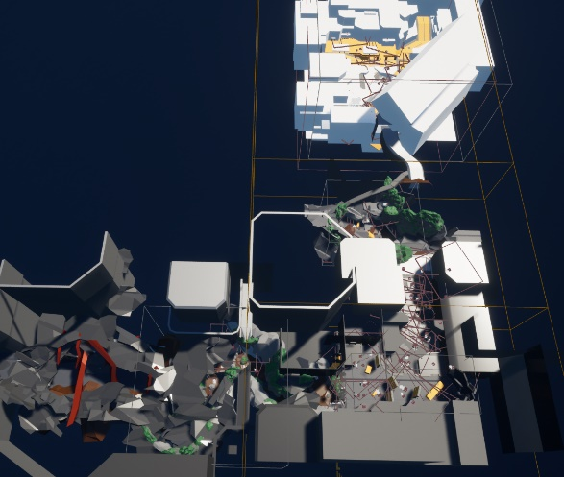This also led me to my initial research idea for my Master's degree: "How can I improve and transform the level design process? Which aspects are most important in level design, how are they applied in the design process, and how do they manifest in game levels? How can I integrate these elements into a template, pattern, or methodology that allows inexperienced individuals like myself or those people with no relevant experience to create complete and high-quality level designs?"

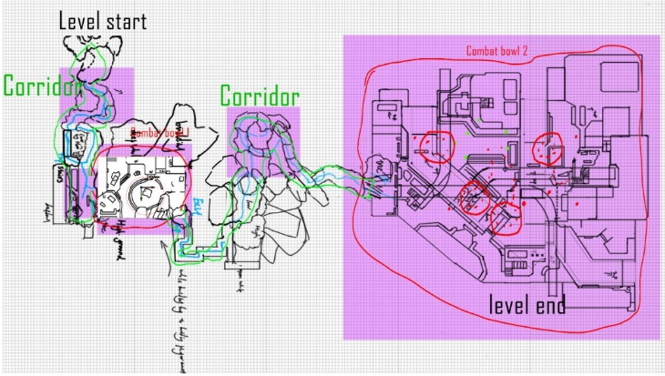 Year 3 capstone final version

Research Question:

How to use level design in third-person adventure games to influence combat, storytelling, and guidance for an immersive gameplay experience also establishes a connection with the game's characters. How is the design of combat, storytelling, and guidance reflected and implemented in the game levels?

Filed Of Inquiry:

This research project is to explore how level design works in the game elements of combat, narrative, and guidance, and how they are used in a scene within a level. Through extensive case studies, principle analysis, and prototype production, this project will demonstrate the elements involved in level design, using third-person adventure game as an example to provide clear and concise design guidelines and examples for peers who want to try designing their own levels.

Keywords:

Third-person cover base shooter game, Level design, Combat area, Environmental storytelling, wayfinding, Level design patterns， Implementation， High quality level design, Design template

Aim 1:

Move beyond the theory of level design and apply it in practical level design.

Gather theoretical knowledge on level design, establish connections between combat, narrative, guidance, and levels, and conduct case studies to observe and collect successful and highly-rated third-person adventure games to analyze their designs. By integrating the collected information, methods, and theories, this project aims to visualize how they are used in level design and create an improved methodology that can be shared with peers as a tool thesis.

Aim 2:

Combat:

How does level design affect players' combat experience?

How are combat arenas designed in other games?

Narrative:

How is storytelling integrated into levels?

How are third-person cinematic narrative games created, such as The Last of Us and Uncharted (which can be considered a road movie)?

How are environments used to drive the plot of the story?

Can levels create empathy between players and characters, leading to a process of character personality development where players come to like their characters or hate someone?

What did other games do to represent the character's personality using the environment? What item, action, or thing can be used to do it?

Guidance/ Hints:

What visual and psychological elements can be used to guide players?

What are the goals of player guidance, and where should players be guided to?

How can players' curiosity be piqued and maintained throughout the level?

Should players be guided towards good or bad places, and what can they gain from it?"

The test of Guidance using parallax illusion and sound illusion in DP1.